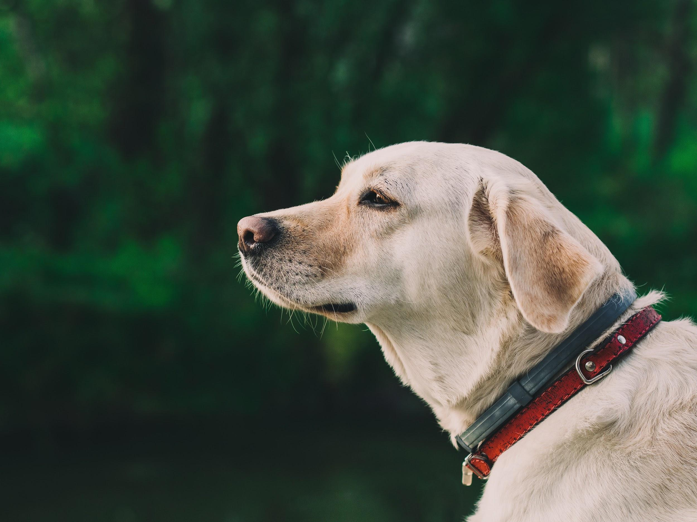
Photo via Pexels

How to Keep Your Senior Dog Happy and Healthy

It’s hard to watch your beloved pet grow old. Although they may not be able to join you on your long hikes or chase birds like they used to, your dog can still enjoy their senior years with proper care. It's important to watch your dog for signs of aging so you can prevent any potential problems commonly faced by senior dogs and keep them happy. Here are some ways you can maintain your dog's quality of life as they get older.

Purchase Helpful Tools for Your Pet

There are several accessories that can make your aging pet’s life easier. For example, many larger senior dogs can benefit from elevated food and water bowls to reduce discomfort in their neck when feeding or drinking. If your dog tends to slide around on hard floors, consider picking up some grippy pet booties so they can roam your house with confidence. Slip-proof rugs can also be helpful. Additionally, older dogs often have trouble jumping up and down from cars or sofas, so pet stairs and ramps can make a significant difference in their lives and mobility. These come in a variety of options for various dog sizes and breeds — check out online reviews before buying to help you find the perfect product for your pet.

Make Your Pet Safer Indoors

Senior dogs often experience a loss of balance and sight, causing them to knock into things when they’re walking around. This also makes them prone to tripping and falling in the home. Keep your house free from clutter and pad sharp corners to protect your pet from injury. Since older pets tend to have memory problems and can get disoriented in the home, make sure their bed, toys, and water bowl are in easily accessible locations.

Stimulate Their Mind

Like humans, dogs experience cognitive decline as they get older. Fortunately, there are many activities you can do with your pet to keep their mind sharp. When you take your dog out for walks, try to expose them to new sights, smells, and sounds — changing and complex environments have the greatest mental benefits. You can also engage your pet with problem-solving activities such as playing hide and seek with their favorite toys and treats.

Feed Your Dog a Balanced Diet

Older dogs have different nutritional needs than younger pets. For example, older dogs often need fewer calories to maintain a healthy weight but still require plenty of important nutrients like protein, fat, and fiber. You can buy senior dog food, but there are no guidelines that companies must follow to claim that a food is good or beneficial for senior pets. So, instead, look for an AAFCO statement affirming that the food is complete and balanced. You can learn more about dog food labels from Animal Wellness Magazine.

Pay Attention to Their Dental Health

Dental disease is extremely common in dogs. In fact, Canna-Pet claims that 80 percent of dogs have some amount of periodontal disease before the age of two. Poor dental health can cause mouth pain and even lead to serious problems with the heart and liver. You can prevent dental problems by brushing your dog’s teeth every day with special dog toothpaste. Give your pet bones and chew toys to help scrape their teeth clean and massage their gums. It’s also important to take your pet to the vet on a regular basis and have their oral health evaluated. That way, you can have any potential problems treated before they become too serious.

Keep Your Dog Warm

Cold and wet weather can cause stiff joints and discomfort for older dogs, so try to keep them warm during the winter. Indoors, provide blankets and hot water bottles in your pet’s bed. It’s also a good idea to keep the heat turned up in the room where your dog sleeps. If your pet’s bed is on a hard floor, adding a small rug underneath can help ward off some of the cold. Also, cozy dog jackets can help them stay warm when you go outside.

With proper care and lots of love, your senior dog can live a long and happy life with you. Try to be patient with them and understand that they may need a bit more time to respond to commands. In the end, treating your pet with respect is the best way to maintain a strong bond between the two of you for years to come.

